**ms**

**Table of contents**

Wlcome screen…………………………………………………………………………………………………………………..2

Join a game………………………………………………………………………………………………………………………..3

Host a game……………………………………………………………………………………………………………………….4

Free play game…………………………………………………………………………………………………………………..5

Making a new free play profile………………………………………………………………………………7

Menu options in creating a new free play proflie screen……………………………………….8

Free play profile example………………………………………………………………………………………10

Starting game dialog…………………………………………………………………………………………………………..11

Scoring………………………………………………………………………………………………………………………………..12

Options……………………………………………………………………………………………………………………………….13

Market………………………………………………………………………………………………………………………………..14

Ranking games…………………………………………………………………………………………………………………….15

Welcome screen:

C:\Users\Yoav\Desktop\shots\optionButton.png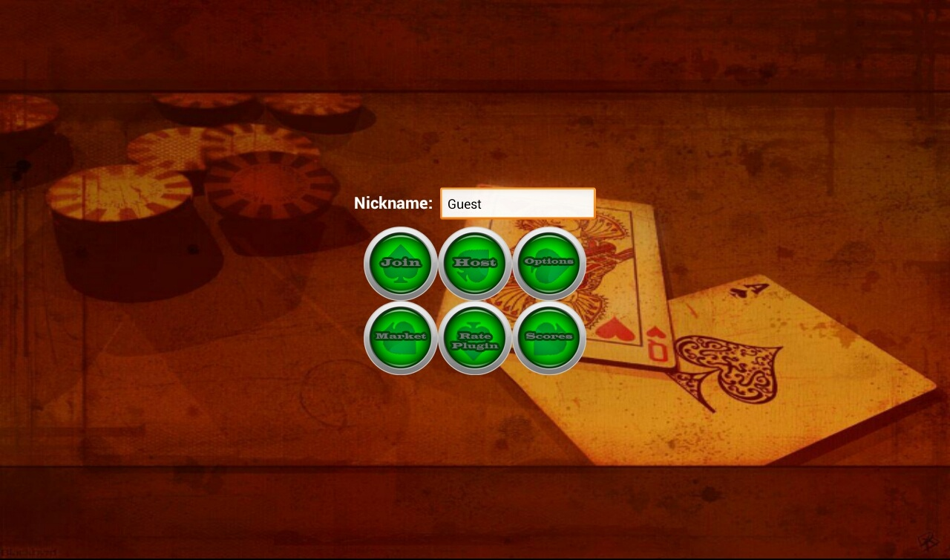

Pressing the android options button:

will pop up a menu that allows you to take the tutorial and learn about the main features of the app.

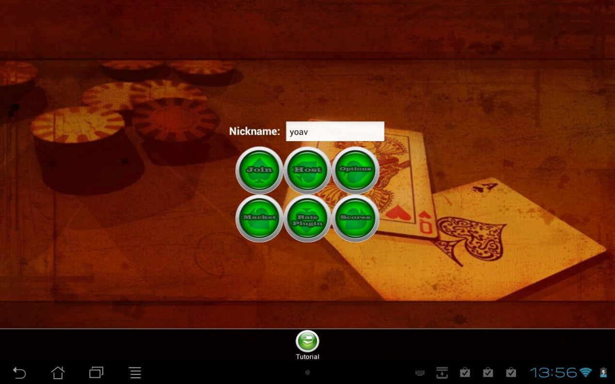

Joining a game:

Pressing the Join button in the main menu will lead to the following screen, where you can see all the available games you can join.

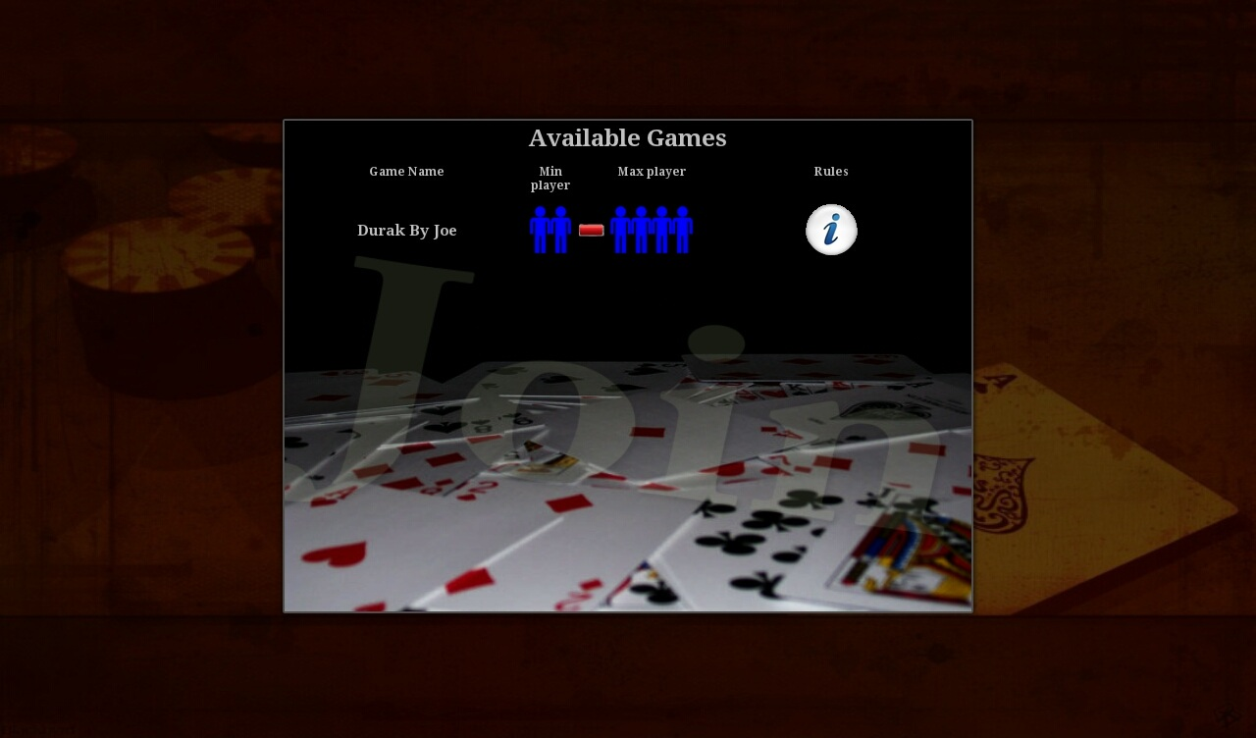

* Game name: indicates the type of the game and who hosts it.
* Min players: the amount of players required to start the game.
* Max players: the maximum players that can join the game.
* Rules: by pressing the rules button, a new dialog will pop up and explains the

rules of the game.

Hosting a game:

Pressing the Host button in the main menu will lead to the following screen, where you can see all the available games you can play.

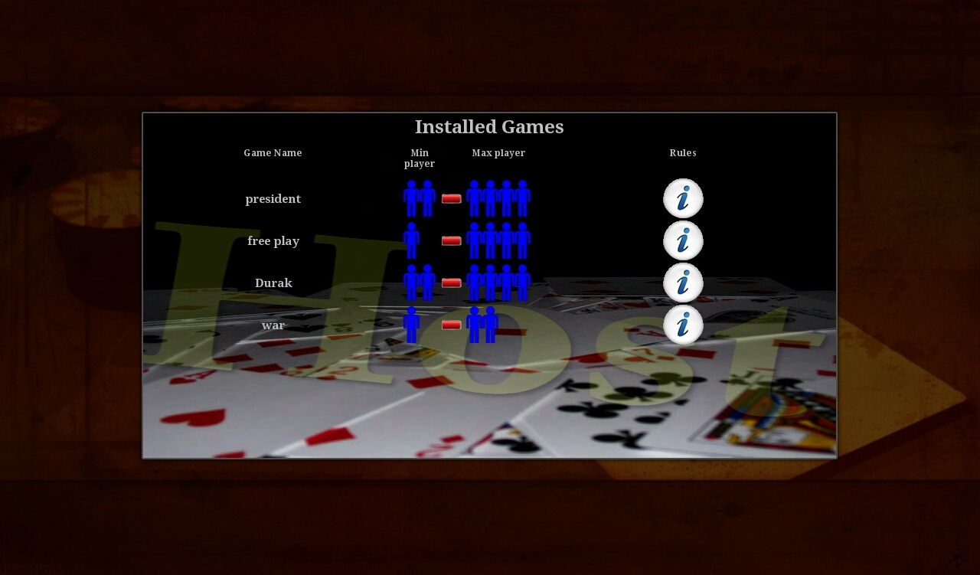

The table index is the same to the Join table index.

* Game name: indicates the type of the game and who hosts it.
* Min players: the amount of players required to start the game.
* Max players: the maximum players that can join the game.
* Rules: by pressing the rules button, a new dialog will pop up and explains the

rules of the game.

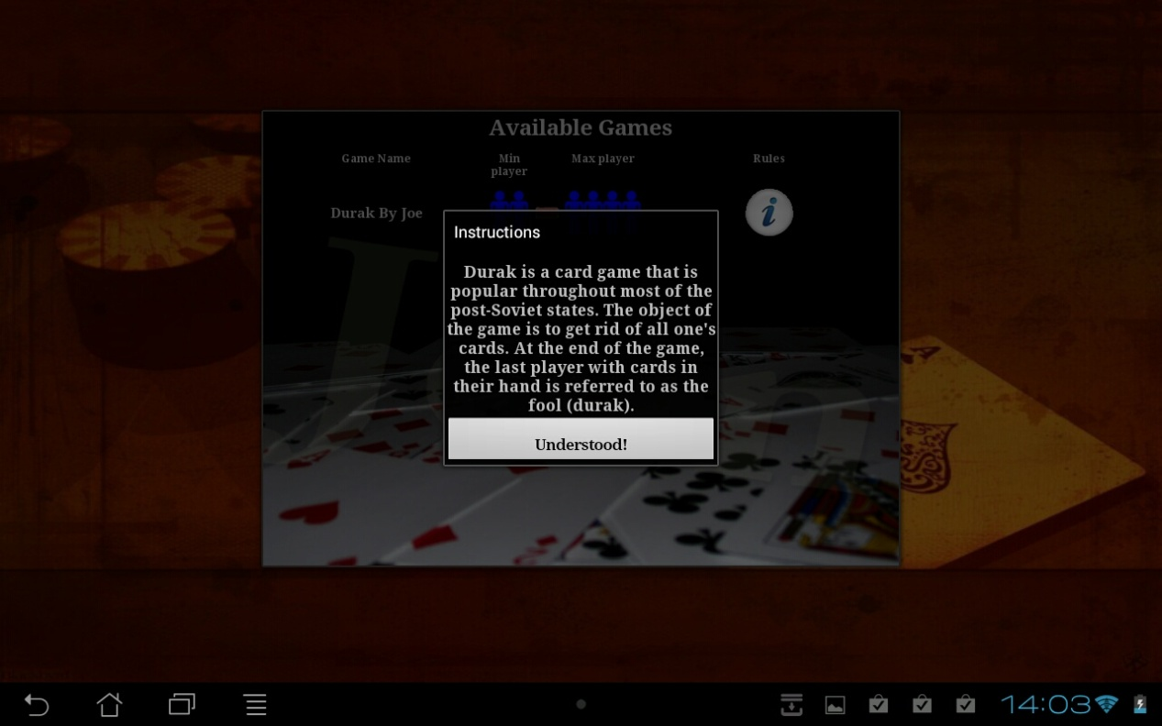

Free play game:

The free play game type is one of the highlights (out of many others) of our app.

Free play game can be played solo or with 4 friends.

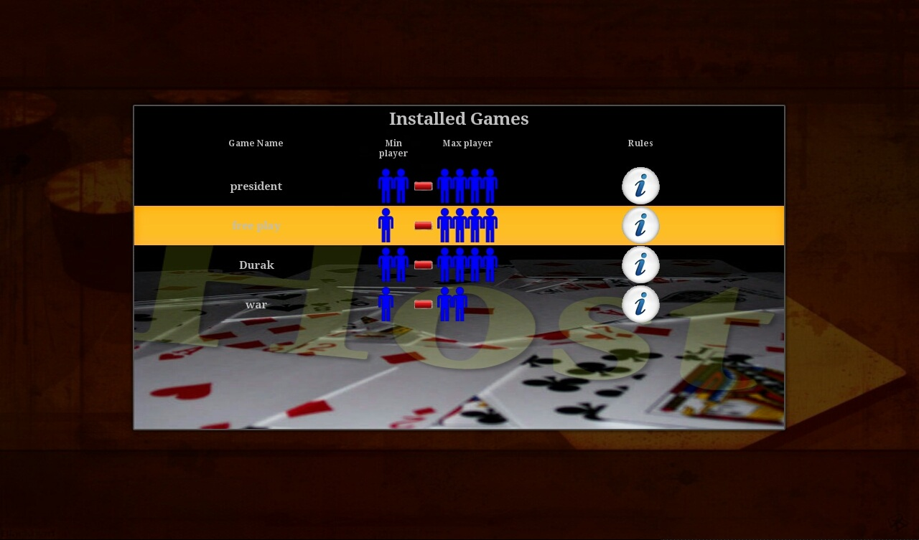

Pressing the free play game will lead to a profiles page:

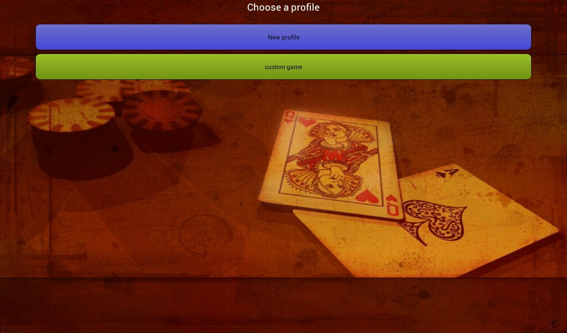

Here you can create a new profile, use, edit or delete one of your profiles.

Chosing one of your profiles will start the game according to that profile,

Long press on one of them will enable you to edit or delete that profile

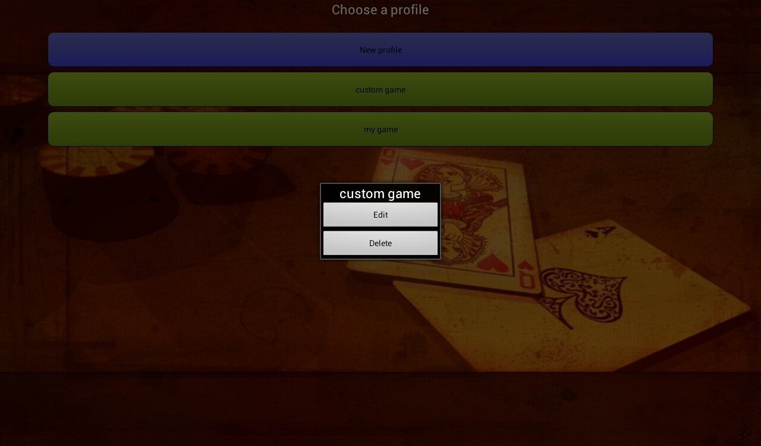

Notice that the title of that dialog will be the same as the name of the profile the action will be performed on.

Making a new profile:

By pressing the "New profile" button, a new "editable" screen will appear

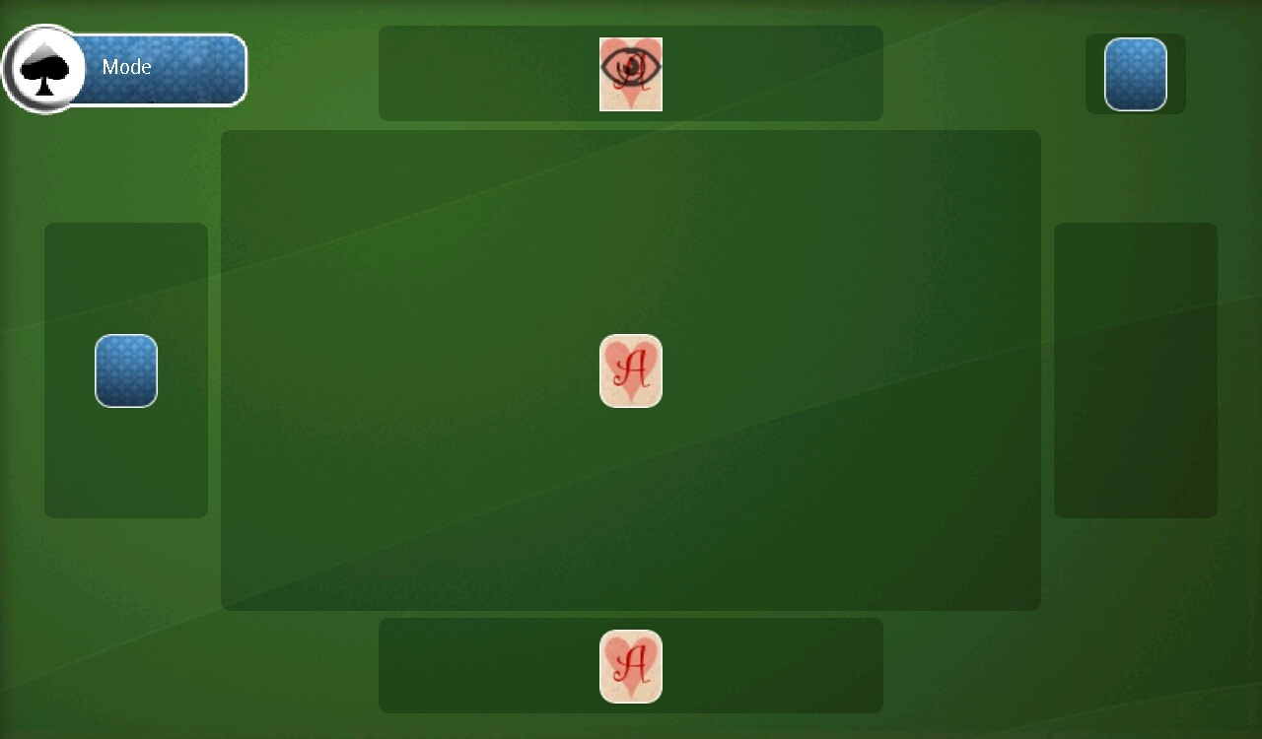

When clicking a player area a card will be shown on that player, all player areas with cards on them represents the maximum players of our profile, in our example maximum players is 3.

Each click on a player area results in a different type of behavior, marked by the yellow arrow:

1. Only the player can see his own cards.
2. All players in the game can see that player's cards.
3. No one can see that player's cards.

The mid area represents the public area, all can place cards on it, by clicking it we chose that public area. Revealed card means all cards on that public area will be revealed, hidden card means that all cards on that public area will be hidden.

* D arrow: represents the card deck.
* E arrow: represents the Mode button, clicking on it will swap between the big public area and small public areas.

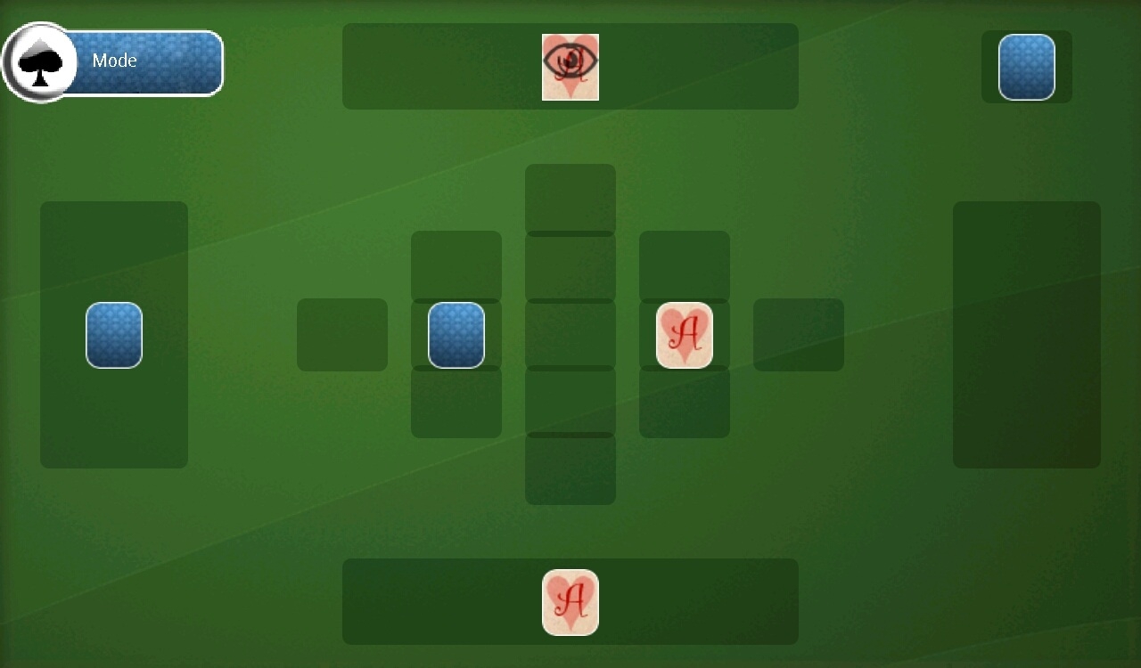

In this screen we chose 2 small public areas:

* Mid left: all cards on that area will be revealed.
* C:\Users\Yoav\Desktop\shots\optionButton.pngMid right: all cards on that area will be hidden.

Pressing the android options button:

Will pop up a menu where we can:

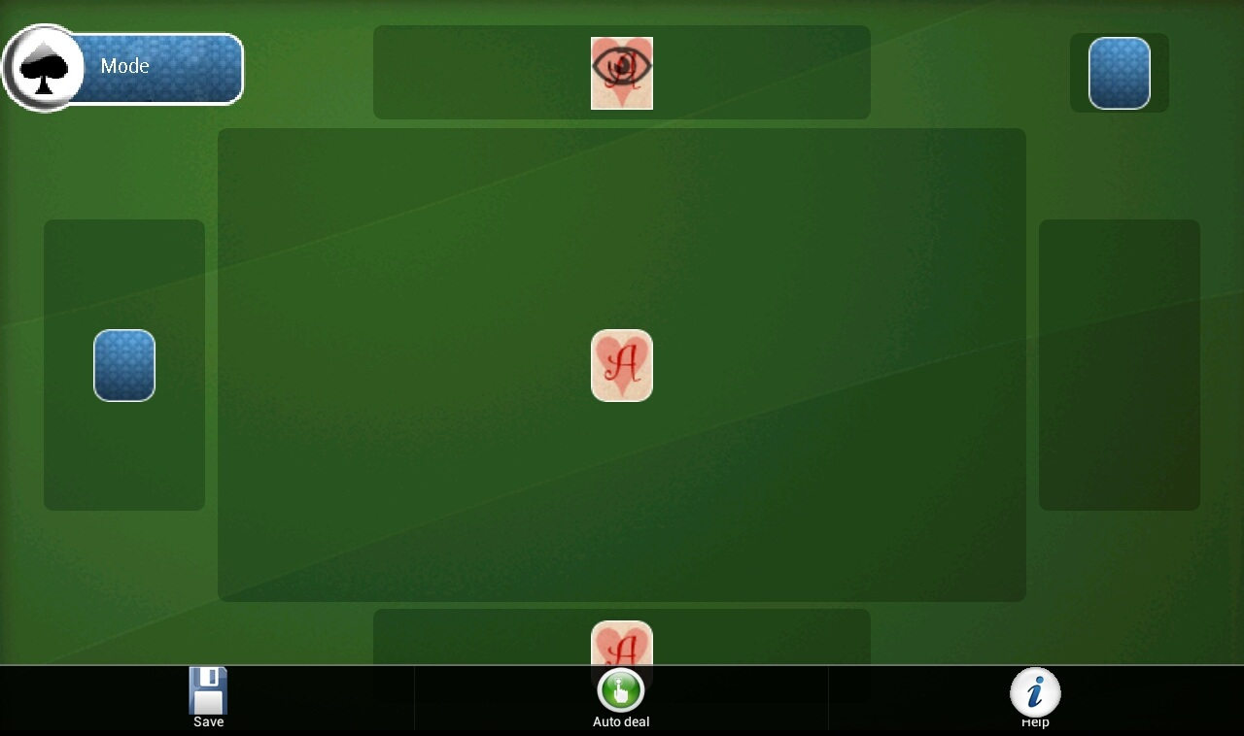

* Auto deal cards:

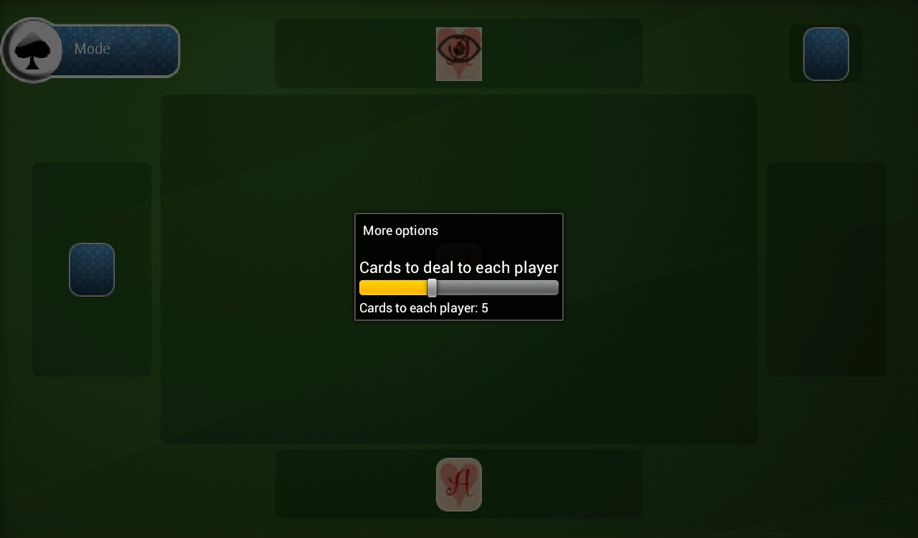

The "Auto deal" button let us chose how many cards will be automaticaly delt to each player when the game starts.

* Save your profile:

The save button pops up the following dialog, where we can name the profile we just made and save it so we can play it.

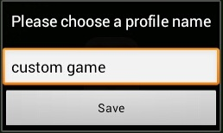

* Get a short explanation about the current screen:

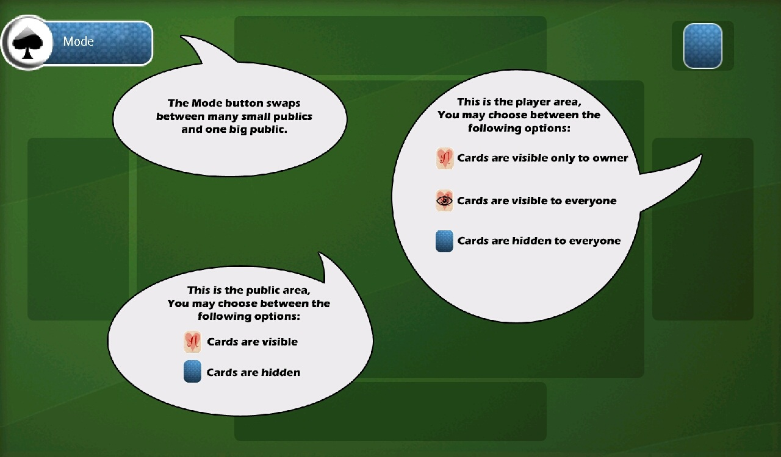

Here is an exmaple of a custom free play game with only one player:

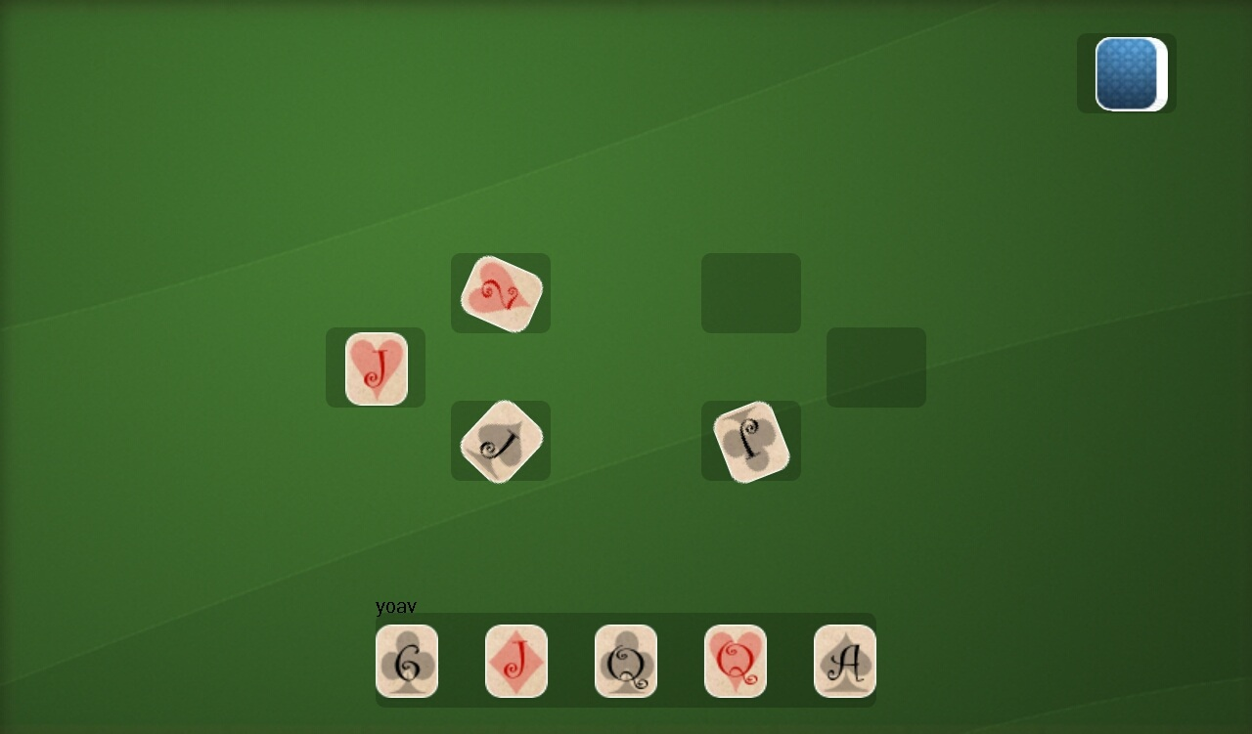

Notice the angle of the cards in the public areas? That's only one of our cool features; you can hold one finger on a card and with your other finger spin it. For more in game features see our tutorial or watch our promo movie.

Starting game dialog:

When starting a game, a dialog will pop if the amount of players that connected to the game reached the minimum requirements.

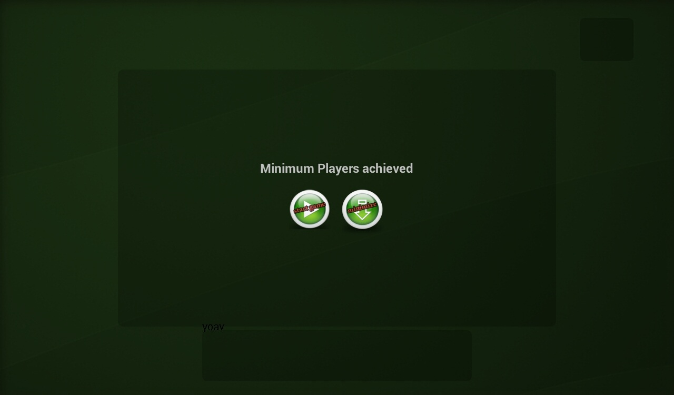

In this dialog the host can choose wether to start the game immediately or minimize it and wait for other players to join the game.

When the amount of players that connected to the game reached its maximum, the game will start automatically.

After minimizing the dialog you can start the game at anytime by pressing the android options button and hit the "start" button.

Scoring:

Some of the games can support scoring. You can see the players' current score during the game by clicking the android options button and then hit the "Rranking" button:



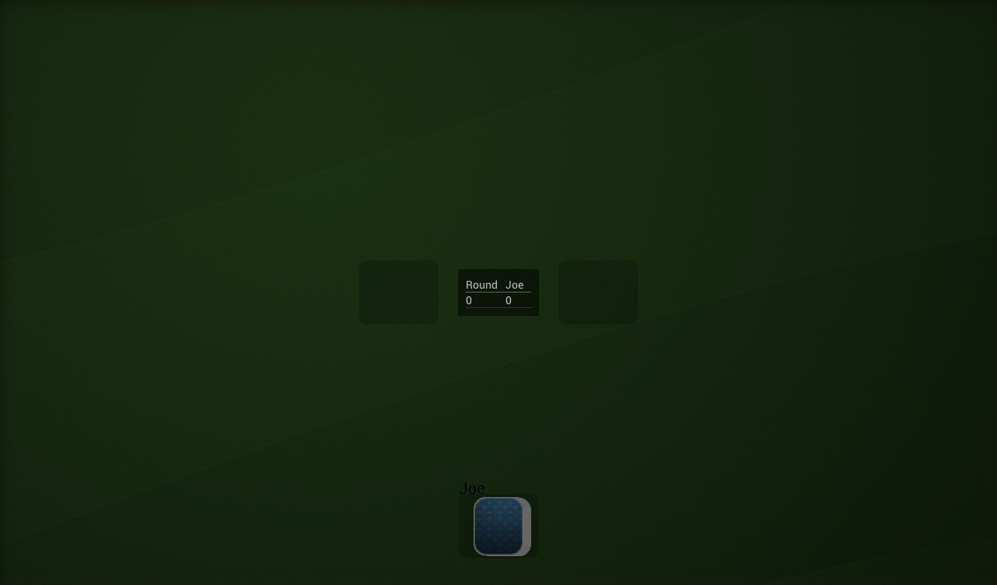

Or at the end of the game by clicking the "Scores" button in the main menu:

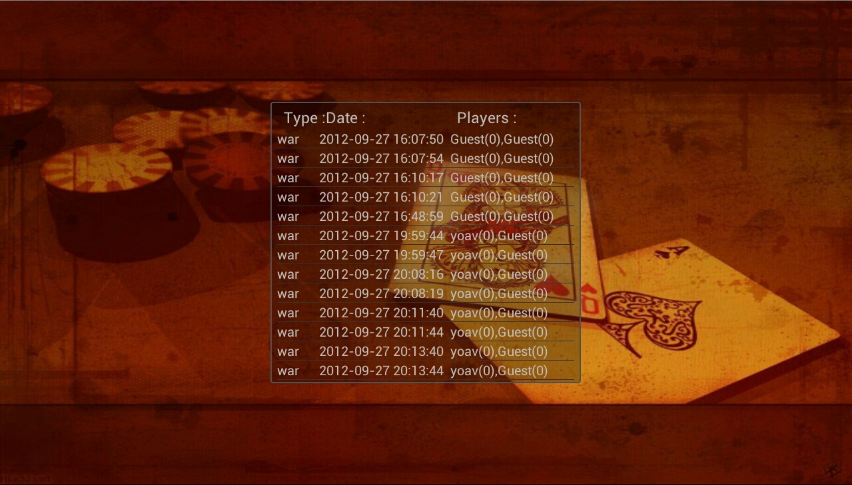

Options:

When pressing the options button in the main menu you get the following options:

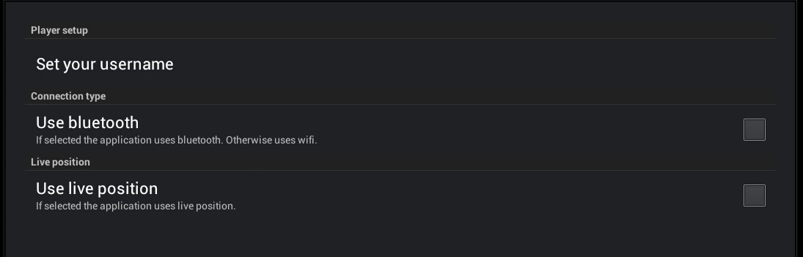

* Set your user name permanently.
* Use bluetooth connection instead of the default Wifi connection.
* Use live position – draw the table dynamically depends on your place in real life, assuming you all sit around a table or even "imaginary table".The system draws the other players according to their position in real life relatively to you.

Host can always stop live position feature in game while pressing the androind options button and hitting "stop live position" button.

Notice: the live position feature is very delicate since it gets your position in real life rapidly, when using it try to sit next to each other in a relatively 90 degrees, just like you sit around a table.

Market:

We made a market especially for our app, in that market other programers can upload a game, using our platform API, that all can enjoy.

After uploading a game at our website: (plugin tab in our website),

all other users can download it from our in-app market and enjoy the game.

Pressing the market button in the main menu gives you a list of available games to download and their rank.

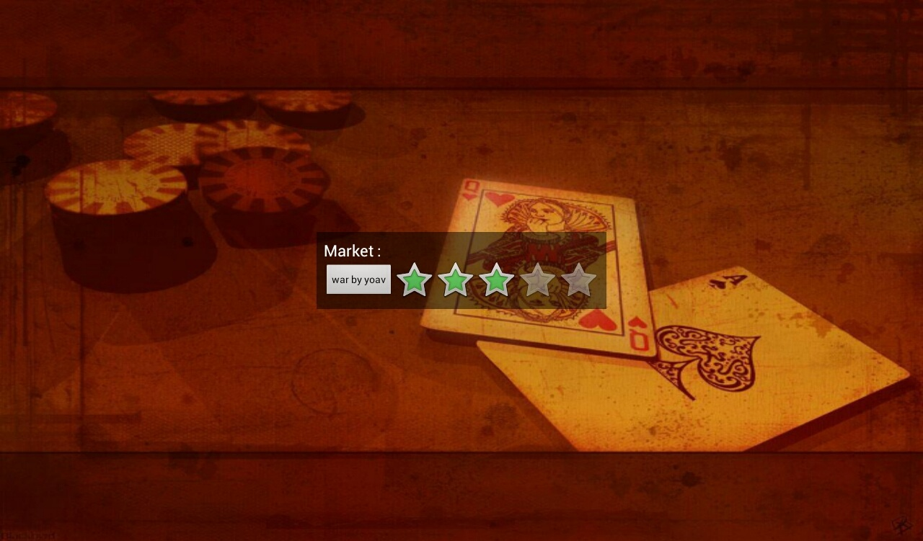

* If someone trying to connect to a game but he doesn't have it on his device, our app will automatically download the game from our market and connect the player to the desired game.

Ranking games:

Pressing the ranking button in the main menu displays a list installed/downloaded games that you can rank zero to five stars. You can only rank game that you downloaded from inside the app and not through the web-site.

